Day 3: Data Visualization
Name: Manish Giri
Registration Number: 137256
Email: manishgiri8101@gmail.com Date: 17-06-2026

Assignment:
Question 1: If you had to visualize the Titanic dataset, which chart would best show survival by gender and class — and why? 🧩 (Encourages you all to connect chart choice with storytelling.)
Answer:
A grouped bar chart would be the best choice because it allows us to compare survival counts across both gender and passenger class (Pclass) at the same time.
Example:
X-axis → Passenger Class (1st, 2nd, 3rd)
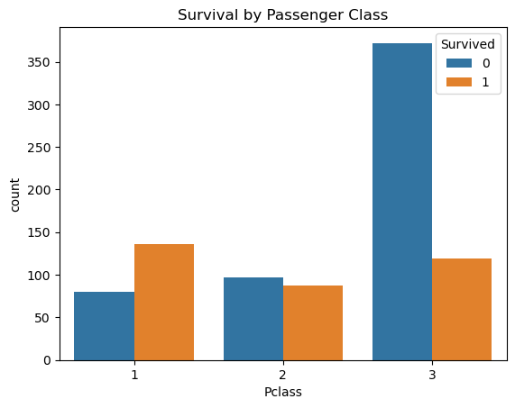
Bars → Male and Female survival counts in each class
0 -> Did not Survived, and 1-> Survived
This makes it easy to see that female passengers and first-class passengers had higher survival rates, helping tell the story clearly.

Question 2: How can poor design choices — like misleading scales or excessive color — distort the message of a visualization? 🧠 (Promotes critical thinking about ethics and clarity in data communication.)
Answer:
Poor design can make viewers draw incorrect conclusions.
Example 1: Misleading Scale
If a bar chart's Y-axis starts at 50 instead of 0, a small difference in survival rates may appear much larger than it actually is.
Example 2: Excessive Colors
Using too many bright colors in a survival chart can distract viewers and make important patterns harder to identify.
Example 3: Same Colors
If we use same colors on different categories we don’t even understand which one belong from which class.
Conclusion:
Good visualizations should be clear, accurate, and easy to interpret, so the data tells the truth without misleading the audience.

